About server configuration and installation

The best operating system to use for ElecRoc server is Windows Server 2008 R2 64 bit. The advantages to running 64 bit OS is that it works better with computer hardware, e.g. chips, and it can manage more RAM.   
The recommended RAM is 4 GB. It’s hard to say the speed advantage of more RAM. If the server runs out of the memory, check it from Windows Task Manager, as following figure, you need to add additional RAM.

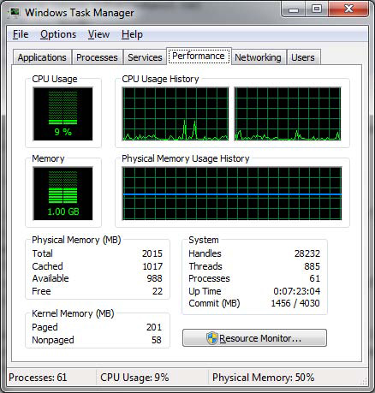

High speed SCSI hard driver is better for the server.   
The recommended hardware for server:   
   Dual-core Xeon 2.66GHz CPU  
   4 GB RAM   
   Windows Server 2008 R2 64 bit   
The recommended hardware for high-end user:    
   4 CPU, quad-core Xeon 2.66GHz or above    
   8 GB RAM   
   Windows Server 2008 R2 64 bit   
With the high-end computer, ElecRoc screen load balancing can be used, and screening speed is quicker one times or more than before.

1. Windows 7 is NOT the recommended OS for ElecRoc server. When you install server on Windows 7, please confirm that user amount is less than 5, and the processing speed may slow. When backup the resources, please use Selective Backup, and deselect PDF & Signature as well as 1-bit TIFF.

2. If the error appears as following when you run ElecRoc 5, please run RestartService from Installer DVD/Tools/Restart Dongle Service, or do it as the report says.

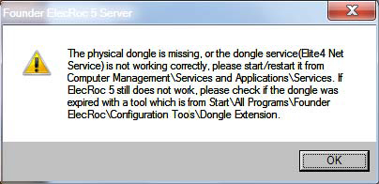

If Elite4 Net Service is running, but the report appears again (as above), please go to Start\All Programs\Founder ElecRoc\Configuration Tools\Processor Configuration (as following figure), copy the Server name and paste into Dongle name’s dialog. Then click Apply, and click exit in the next dialog.

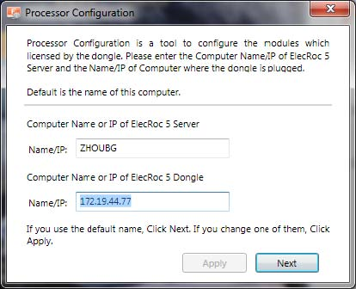

3. If the operating system of server was updated automatically, you need to exit ElecRoc server and restart the computer.

4. If you use a non-English Windows system to install ElecRoc server, you must install the English OS first, then install ElecRoc, after that, change the system langue from English to others, such as Spanish, Portuguese, etc.